**Training Guide for Sales and Customer Support**

## Background:

Healthcare costs continue to rise at an alarming rate, particularly in the United States. This issue presents a major challenge for patients, healthcare and pharmaceutical industries. Kaiser Pamanente (KP), a leading healthcare provider in the US, wants to explore preventative solutions through technological innovations. This is an approach or method that promotes healthy habits, which in return, reduce and possibly eliminates the development of chronic disease, coupled with reduction in cost of diagnosis and treatment of such illness.

Problem Statement

Chronic disease such as Diabetes is affecting quality of lives significantly across age categories. It is a disease that causes damage to large blood vessels of the heart, brain and legs. Also, to small blood vessels, causing problems in the eyes, kidneys, feet and nerves (macrovascular complications). Due to the nature of the disease and how widely spread in the society, the cost of diagnosis and treatment is increasingly high. Healthcare and pharmaceutical industries are faced with uncontrollable costs, projecting 26% increase over a five year period.

Product Goals

The most viable and cost effective preventative approach to reducing and possibly eliminating this staggering cost problem is through controlled healthy habits. This can be achieved with Healthy Living Partner, a mobile app that monitors glucose level, tracks and recommend daily diets, along with appropriate routine exercise activities. The user gets to have total control of daily diets and exercise habits, which will enhance healthy lifestyle. With proper use of this app, the development of chronic disease can be controlled and eliminated, thereby allowing healthcare providers to save significantly on costs to diagnose and treat less severe cases.

## Market background:

### Target Audience

Healthy Living Partner app is designed for adults within 45 to 75 years of age or anyone that is health conscious. The highest number of diabetes cases is known to be the highest among this age group or category. An ideal customer or user will be someone with Type_2 Diabetes or similar type of chronic disease, as well as, anyone interested in adopting healthy lifestyle habits.

### Target Market

This app fits into a variety of markets. Specifically, healthcare, wellness and fitness segments of a broad market much to the fact that it combines healthy diet options, wellness activity resources along with monitoring and performance capabilities, thereby serving as a conduit to preventing diabetes or other chronic illness.

The goal is to roll the product out to individual users, collaborate with healthcare providers and health insurance sales distribution channels.

### Competition

Momentum by Apple/Maehlum and Habitbull by Appholdings are some of the competitions for the Healthy Living Partner. The core strength of these competition products is centered on training the human system to add or drop habits. While the competition’s main focus is on boosting the will power and training human system on habits, the Healthy Living Partner incorporates Glucose or Blood Sugar-level Monitor, bundled with Activity Mate and API, thereby providing the user with a wide range of control of key components of healthy living.

The Healthy Living Partner solution offers a win-win environment for patients, healthcare providers, pharmaceuticals and the society in general. Healthcare can be truly affordable if we can live healthier.

## Product Background:

Healthy Living Partner is a subscription based mobile app that monitors, tracks, and recommends diet and exercise activities. It provides user performance data analysis, as well as Application Programming Interface (API) for integration with other complimentary products.

For wellness and healthy lifestyle enthusiasts that want to take advantage of state- of-the-art apps that offer easy and convenient access to preventative monitored diet and exercise routine, Healthy Living Partner is the one-stop-shop app for healthy lifestyle habits anywhere at any time. It combines all the essential components of health and wellness into one.

### Features

1. Diet Assistant - Provides the user with a healthy diet list for Breakfast, Lunch and Dinner, including options for recommended diet combination. Users can select and follow guidance.
2. Exercise Activity Mate - Offer users a wide variety of exercise activities specifically tailored for ensuring adequate blood flow and burning calories, thereby allowing d proper body weight maintenance.
3. Glucose Monitor - The feature is a critical piece that allows users to keep track of the blood sugar-level, including threshold crossing notification capability.
4. Performance Monitor
5. API - The Application Programming Interface provides a flexible means of integration with other products to access or transfer data.

### Benefits to users

* Quick analysis of health status for the users, allowing them to be aware of current health condition
* Easy access to healthy diet list with recommendations
* Easy access to exercise activity list with recommendations
* Quick analysis of users performance and commitment task completion and change in lifestyle
* Accurate monitoring of body Glucose level

### How to use the product

Healthy Living Partner provides guides and recommendations to users as they approach and go through daily diet, exercise and health monitoring routine. It is the go-to-place for habit and lifestyle formation and modelling.

#### Health Status Check (Health Status)

Provides analytical report of user health condition

When the user signed on to the app, the user is taken to the Main Menu page, with a list of different options. The user selects Health Status, and will be required to input some information. The app will then analyze and return with a report on the user’s health status. The goal is to give the user an insight to the level of urgency that will be required for his or her routine.

#### Diet Assistant (Diet List)

Provides a list of diet menu with recommended options for Breakfast, Lunch and Dinner

Entering the Main Menu page, Diet List button is one of the options. Users can select the button and will have access to a diet list. Users will also be presented with the options for Breakfast, Lunch or Dinner.

#### Exercise Activity Mate (Exercise List)

From the Main Menu page, one of the option buttons is the Exercise List. Selecting this button will give access to a list of exercise activities from which the user can select. There are more options for recommended activities.

#### Glucose/Sugar-Level Monitor (Glucose Monitor)

The Glucose Monitor can be accessed from the Main Menu page by selecting the Glucose Monitor button. After supplying the required input, the Glucose Monitor will display the reading of the measure of blood sugar-level.

#### Performance Monitor (Performance Monitor)

Provides the user with an analysis and percentage rating of completion of tasks in a routine.

This is another option available on the Main Menu page. Select the Performance monitor button after completing an exercise routine. Users will get a display with analysis of the measure of completion, which transforms to level of achievement of and commitment to healthy lifestyle practices.

#### Application Programming Interface (API)

This feature is a technical development component purposely for integration with other complimentary products. API documentation is provided to developers upon request.

### Where users can find the product

Healthy Living Partner app is available for purchase at the Appstore/Playstore

### The Healthy Living Partner mobile app

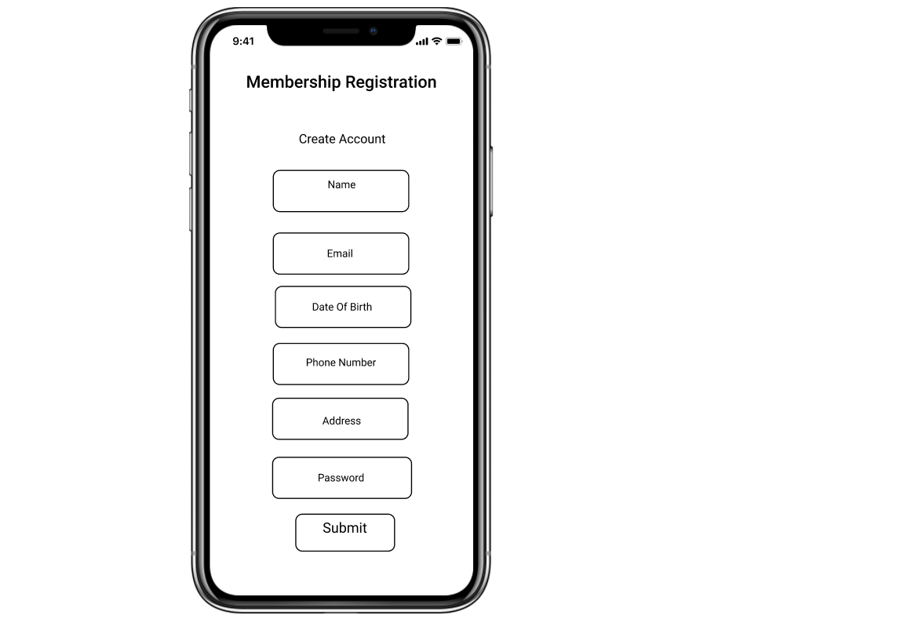

[Prototype Link: Healthy Living Partner](https://www.figma.com/proto/jWkYF0Wsq68aAYEP54olw6/Healthy-Living-Partner-(New)?node-id=7%3A0&viewport=502%2C233%2C0.2484641671180725&scaling=scale-down)

## Pricing:

The initial strategy for pricing is to go-to-market with competition pricing. Once users get to experience the value and the depth of offering in the product, then a change in price will be implemented in the future.

* Monthly Subscription - $4.95
* Yearly Subscription - $45.95